
The Islamia University of Bahawalpur

Car Wash Appointment

A project presented to
Department of Information Technology
Islamia University Bahawalpur

In partial fulfillment
of the requirement for the degree of

Bachelor of Science in Information Technology (2022-2026)

By

Tania Ajmal
F22BINFT1E02057
2022_2026

DECLARATION
We hereby declare that this software, neither whole nor as a part has been copied out from any source. It is further declared that we have developed this software and accompanied report entirely on the basis of our personal efforts. If any part of this project is proved to be copied out from any source or found to be reproduction of some other. We will stand by the consequences. No Portion of the work presented has been submitted of any application for any other degree or qualification of this or any other university or institute of learning.

Student Name

Tania Ajmal

CERTIFICATE OF APPROVAL

It is to certify that the final year project of BS (IT) Car Wash Appointment was developed by
Tania Ajmal, F22BINFT1E02057, 2022-2026 under the supervision of Mam Sara Farid and that in (her) opinion; it is fully adequate, in scope and quality for the degree of Bachelors of Science in Information Technology.

Supervisor

-----------------------------------

External Examiner

------------------------------------

Chairman Department of Information Technology

-----------------------------------

Acknowledgement

First and foremost, I am deeply thankful to Almighty Allah for giving me the strength, patience, and knowledge to successfully complete this Final Year Project.
I would like to express my sincere gratitude to my project supervisor Mam Sara Farid for their continuous guidance, support, and valuable feedback throughout the development of the Car Wash Appointment App.I am also thankful to my department faculty members for their assistance and encouragement during the various phases of the project, especially in design, development, and testing stages.This project was developed using Android Studio with the Java programming language, and I would like to acknowledge the importance of these tools and technologies in helping me bring my ideas to life.I would also like to thank my friends and classmates, who provided helpful suggestions and participated in the testing phase to ensure the app met its functional requirements.Finally, special thanks to my family for their constant support, motivation, and prayers throughout this journey.

Student Name
Tania Ajmal

Abbreviations

Provide a list of all abbreviation used in the document.

SRS | Software Require Specification
PC | Personal Computer
Ul | User Interface
UX | User Experience
API | Application Programming Interface
DB | Data Base
FYP | Final Year Project
XML | Extensible Markup Language
JVM | Java Virtual Machine
SDK | Software Development Kit
APK | Android Package
OS | Operating System
CRUD | Create, Read, Update, Delete
IDE | Integrated Development Environment

Table of Contents
1 Introduction 1
1.1 Brief 1
1.2 Relevance to Course Modules 1
1.3 Project Background 1
1.4 Related Material and Literature 1
1.5 Analysis from Literature Review (in the context of your project) 1
1.6 Methodology and Software Lifecycle for This Project 1
1.6.1 Rationale behind Selected Methodology 1
2 Problem Definition 2
2.1 Problem Statement 2
2.2 Deliverables and Development Requirements 2
2.3 Current System 2
Figure 2.1: Sample picture 2
3 Requirement Analysis 3
3.1 Use Cases Diagram 3
3.2 Functional Requirements 3
3.3 Non-Functional Requirements 3
4 Design and Architecture 4
4.1 System Architecture 4
4.2 Data Representation [Diagram + Description] 4
4.3 Process Flow/Representation 4
5 Implementation 5
5.1 Algorithm 5
5.2 External APIs 5
5.3 User Interface 5
6 Testing and Evaluation 6
6.1 Manual Testing 6
6.1.1 System testing 6
6.1.2 Unit Testing 6
6.1.3 Functional Testing 7
6.1.4 Integration Testing 7
6.2 Automated Testing: 8
7 Conclusion and Future Work 9
7.1 Conclusion 9
7.2 Future Work 9

1 Introduction
This chapter provides an overview of the Car Wash Appointment App, a mobile-based solution designed to simplify and streamline the process of scheduling car wash services. The application aims to eliminate the traditional hassle of long queues and uncertain wait times by allowing users to conveniently book appointments from their smartphones.
The Car Wash Appointment App enables users to view available service providers, select preferred time slots, and confirm bookings with just a few taps. It provides a user-friendly interface and ensures seamless interaction between customers and service centers . The system integrates core features such as appointment scheduling, time slot management, booking confirmation, and service history tracking.
With the growing need for digitized and efficient vehicle service systems, this app offers a modern and practical approach to managing car wash appointments. The project reflects strong competence in mobile app development and focuses on enhancing customer convenience, operational efficiency, and service provider coordination.

1.1 Brief
The Car Wash Appointment App is a mobile application designed to offer a convenient and efficient solution for booking car wash services. The project leverages modern Android technologies and secure payment integrations to provide users with real-time access to available car wash providers, appointment slots, and service options. Key outcomes include a user-friendly interface, streamlined appointment booking, service customization, and secure online payment options
1.2 Relevance to Course Modules
The development of the Car Wash Appointment App aligns closely with several key courses undertaken during the BS program, demonstrating the practical application of theoretical knowledge in a real-world mobile application project.
- Object-Oriented Programming (OOP):
The app uses a modular structure with well-defined classes such as User, Booking, Time Slot, and Service Type. Concepts like encapsulation and inheritance help manage logic cleanly and promote scalability.
- Mobile Application Development:
Core Android development skills were applied, including activity lifecycle management, use of Recycler Views for displaying car types and time slots, and implementing click listeners for user interaction. The user interface was designed using XML layouts to ensure responsiveness and ease of navigation.
- Data Structures and Algorithms:
Lists and arrays were used to manage dynamic data such as available time slots and car wash categories. Basic algorithmic logic was implemented to handle slot availability and booking conflicts efficiently.
- Database Management Systems (DBMS):
Though the current implementation uses static data, the app is designed to support database integration in the future for storing booking records, customer profiles, and appointment histories. This reflects understanding of relational schema and CRUD operations.
- Human-Computer Interaction (HCI):
The UI/UX design prioritizes user-friendliness with clearly labeled buttons, intuitive booking flow, and feedback prompts. Principles like simplicity, consistency, and error prevention were applied to improve usability.
- Software Engineering:
The software was built following a structured development process, including requirement analysis (SRS), design modeling (SDD), and modular implementation, mirroring key software engineering practices taught during the course.

1.3 Project Background
The concept behind the Car Wash Appointment App emerged from the increasing need to digitize and simplify the traditional process of scheduling car wash services. In many urban and semi-urban areas, customers often face challenges such as long wait times, lack of appointment systems, and inefficient communication with service providers.
This project was initiated to create a smart and user-friendly platform where customers can book car wash appointments in advance, select their preferred time slots, and receive confirmations — all through a mobile application. The motivation was to reduce time wastage, improve customer satisfaction, and support service providers in managing daily bookings more effectively.
Unlike conventional methods that rely on walk-in visits or manual registers, the Car Wash Appointment App introduces a modern and efficient solution by offering:
- A time-slot-based booking system that allows customers to choose convenient washing times.
- A clean and intuitive interface for browsing services and confirming appointments with just a few taps.
- Potential integration with databases in the future to store booking history, customer details, and service preferences.
The project reflects a practical application of mobile development skills and demonstrates how technology can be used to improve everyday service interactions.

1.4 Related Material and Literature
The development of the Car Wash Appointment App for a specific car wash shop is based on current trends and research aimed at improving customer service and operational efficiency through digital solutions tailored to a single service provider.
1.4.1 Current Trends in Single-Shop Service Apps
With increasing demand for convenience, many individual car wash businesses are adopting dedicated mobile apps to manage bookings and customer relationships more effectively. Key trends include:
- Dedicated Booking Management: Apps designed specifically for one service location, enabling precise control over available time slots and resource allocation.
- Personalized Customer Interaction: Features like loyalty programs, custom service packages, and direct communication channels improve customer retention.
- Service Customization: Allowing customers to select from tailored service options such as interior cleaning, waxing, or express wash.
1.4.2 Research and Development
Research efforts in this domain focus on optimizing the digital interaction between a service provider and its customers. Important areas include:
- Optimizing Appointment Flow: Algorithms to prevent overbooking and ensure efficient utilization of staff and equipment.
- User Experience Design: Creating simple and intuitive interfaces that guide customers through the booking process quickly.
- Data Security and Privacy: Safeguarding customer information in line with best practices and regulations.
1.4.3 Relevance to This Car Wash Appointment App
This application incorporates these trends by offering a focused platform that reflects the specific services and scheduling preferences of a single car wash shop. It provides real-time visibility into available slots, a clear presentation of service options, and streamlined booking confirmation.
By specializing for one shop, the app ensures better operational alignment and customer satisfaction. Future enhancements may include integration with payment gateways, loyalty features, and detailed analytics for business improvement.

1.5 Analysis from Literature Review (in the context of your project)
The literature review highlights important advancements in service appointment applications, emphasizing improved scheduling algorithms, user-friendly interfaces, and enhanced communication between service providers and customers. These factors are essential in creating efficient and satisfactory booking experiences in modern service industries.
In comparison, the Car Wash Appointment App integrates these advancements by offering a focused solution tailored to a single car wash shop. It implements a time-slot based booking system that prevents overbooking and facilitates easy appointment management. The app’s clean interface and straightforward booking flow improve user satisfaction, while the provision for notifications and reminders aligns with best practices identified in recent research.
1.6 Methodology and Software Lifecycle for This Project
The Car Wash Appointment App is developed using the Agile methodology, which emphasizes iterative development, continuous feedback, and adaptability to changing requirements. This approach allows the project to evolve through repeated cycles and incremental improvements.

The Software Development Life Cycle (SDLC) model followed for this project is the Incremental Model. The development process is divided into small, manageable increments, with each increment focusing on implementing and refining specific features such as appointment booking, time slot management, and notification delivery.

1.6.1 Rationale behind Selected Methodology

The Agile methodology was chosen because it supports flexibility and responsiveness, enabling the development team to incorporate user feedback and make adjustments throughout the project lifecycle. This iterative process ensures that the application meets user expectations and maintains high quality.
The Incremental SDLC model complements Agile by breaking down the project into smaller components, making it easier to manage, test, and deploy features progressively. This approach reduces risks and facilitates early delivery of functional parts of the application.

Furthermore, Object-Oriented Programming (OOP) principles were applied to structure the app into modular, reusable components such as User, Appointment, and Service classes. This design enhances maintainability, scalability, and code clarity.
The combined use of Agile, Incremental SDLC, and OOP principles ensures a modern, efficient, and user-focused development process suitable for creating a robust and adaptable car wash appointment application.

2 Problem Definition

This chapter outlines the specific problem addressed by the Car Wash Appointment App project. It identifies key challenges faced by both customers and service providers in the traditional car wash appointment process and explains how the proposed solution aims to resolve these issues.
2.1 Problem Statement
Traditional car wash shops often rely on walk-in services or manual appointment booking through phone calls, which results in several challenges:
- Customers experience long wait times, particularly during peak hours.
- Shop staff struggle with scheduling conflicts and service overload.
- Limited record-keeping and tracking of customer preferences and visit history.
The Car Wash Appointment App is designed to resolve these problems by offering a simple, mobile-based platform that allows users to:
- View available time slots and book appointments in real-time.
- Choose from a list of car wash services with clear descriptions.
- Help the service provider manage appointments more efficiently.

2.2 Deliverables and Development Requirements
Deliverables:
- A fully functional Android application for car wash appointment booking.
- A time-slot-based scheduling interface for customers.
- Payment integration.
Development Requirements:
- Platform: Android (Java)
- Architecture: Modular using OOP principles
- Development Tools: Android Studio, XML layouts
- Libraries/Dependencies: Date/Time picker, Notification Manager
- Testing Tools: Android Emulator and real device testing
- Team Members: Individual developer

2.3 Current System
Currently, the car wash shop uses a manual system where customers either walk in or call the shop to book their appointments. This method has the following limitations:
- Appointments can get lost or overlapped due to lack of tracking.
- No mechanism to prevent double bookings.
- Customers must wait in line, leading to dissatisfaction.
- Business lacks insights into peak hours and customer frequency.
The Car Wash Appointment App proposes to replace this inefficient system with a digital, automated solution tailored specifically for the shop's unique schedule and services.

Features | Current System | Proposed System
Appointment Booking | Manual (walk-in/call) | Digital (Via Mobile App)
Time Slot Control | Not Available | Slot Based Selection
Schedule Management | Paper-based | Real-time digital interface

3 Requirement Analysis

This chapter presents a detailed analysis of the system requirements for the Car Wash Appointment App, including use case representation, functional and non-functional requirements as derived from the SRS and SDD documentation.

3.1 Use Cases Diagram

Use Case Diagram for Admin

Use Case Diagram for User

3.2 Functional Requirements
The functional requirements define the expected system behavior and capabilities
- User Registration/Login: The customer must be able to register and log in using valid credentials.
- View Services: The customer should be able to view available car wash services with descriptions.
- Book Appointment: Customers must be able to book an appointment by selecting available time slots.
- Manage Appointments (Admin): Admin should be able to view, approve, cancel, or update customer appointments.
- Update Time Slots (Admin): Admin can define available time slots per day based on staff capacity.
Functional Requirement 1: User Authentication

Identifier | FR-1
Title | User Authentication
Requirements | The user shall be able to register and log in using valid credentials.
Source | Scope Document, SRS And SDD
Rationale | Ensures secure access and personalized experience for users.
Dependencies | Internet connection, authentication database.
Priority | High

Functional Requirement 2: View Services

Identifier | FR-2
Title | View Services
Requirement | The user shall be able to view available car wash services with descriptions.
Rationale | Enables informed decision-making for customers.
Source | User needs
Dependencies | Services database
Priority | High

Identifier | FR-3
Title | Book Appointment
Requirement | The user shall be able to book appointments by selecting from available time slots
Source | Scope Document
Rationale | Provides core functionality for booking car wash services.
Dependencies | User authentication, available time slot data
Priority | High
Functional Requirement 3: Book Appointment

Functional Requirement 4: Manage Appointments (Admin)
Identifier | FR-4
Title | Manage Appointments
Requirement | The admin shall be able to view, approve, cancel, or update customer appointments.
Source | Admin interface requirement
Rationale | Allows proper control and organization of appointments.
Dependencies | Appointment booking system, admin authentication.
Priority | High

Functional Requirement 5: Update Time Slots (Admin)
Identifier | FR-5
Title | Update Time Slots
Requirement | The admin shall be able to define and manage available time slots based on staff capacity.
Source | Admin operations
Rationale | Ensures appointment scheduling is aligned with operational capacity.
Dependencies | Admin panel, staff schedule data.
Priority | Medium

3.3 Non-Functional Requirements
These are system-wide requirements that do not relate to specific functions but ensure performance and reliability:
- Usability: The app interface should be user-friendly and accessible for users with minimal technical skills.
- Performance: The application should be responsive, with booking operations completing within 2 seconds.
- Reliability: The system must be stable and should not crash during normal usage.
- Scalability: Should support future enhancements like online payment.
- Maintainability: The code should follow modular design to allow easy maintenance and updates.
- Security: User data, including login credentials and booking information, must be securely stored and transmitte.

4 Design and Architecture
The following parts of Software Design Description (SDD) report should be included in this chapter.

4.1 System Architecture
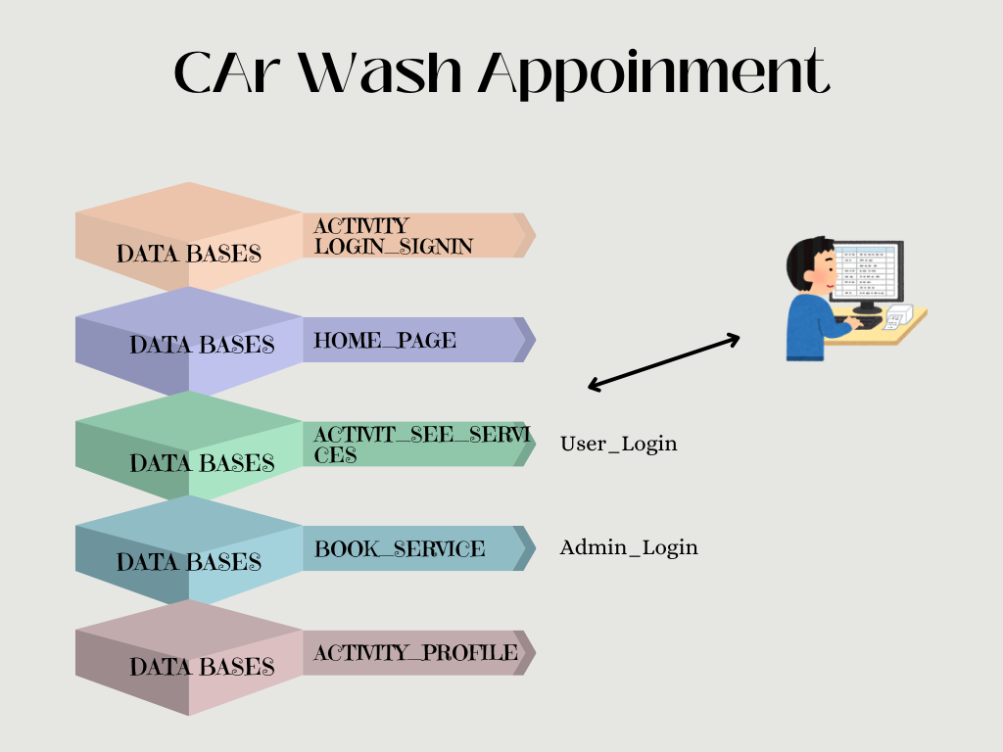

4.2 Data Representation [Diagram + Description]
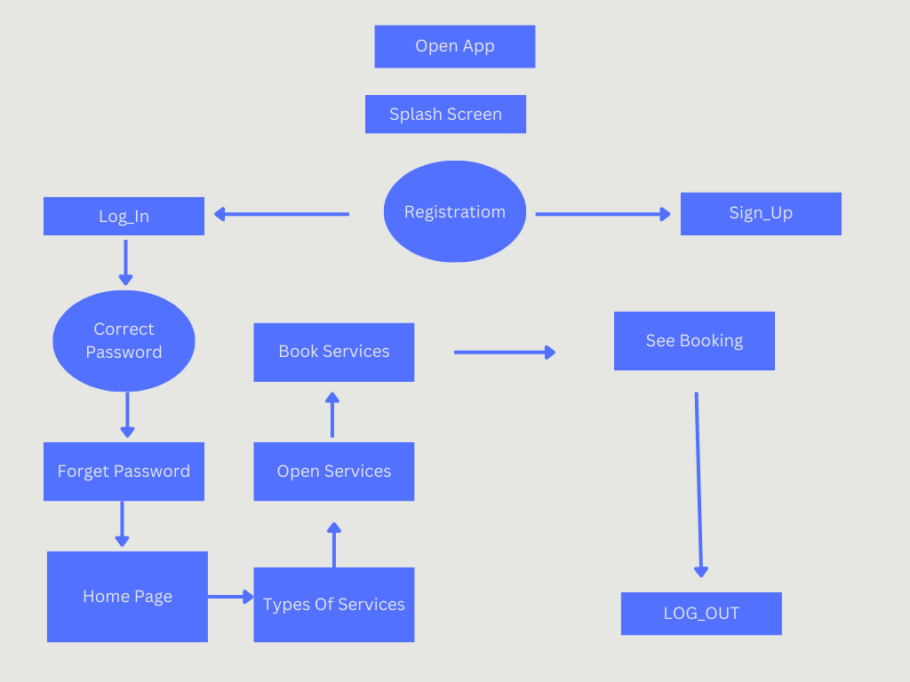

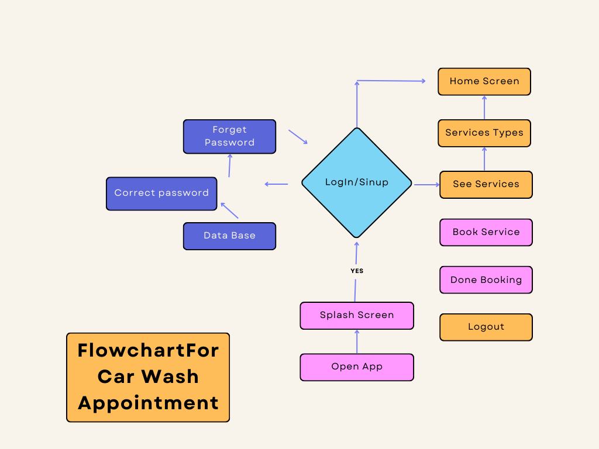
4.3 Process Flow/Representation

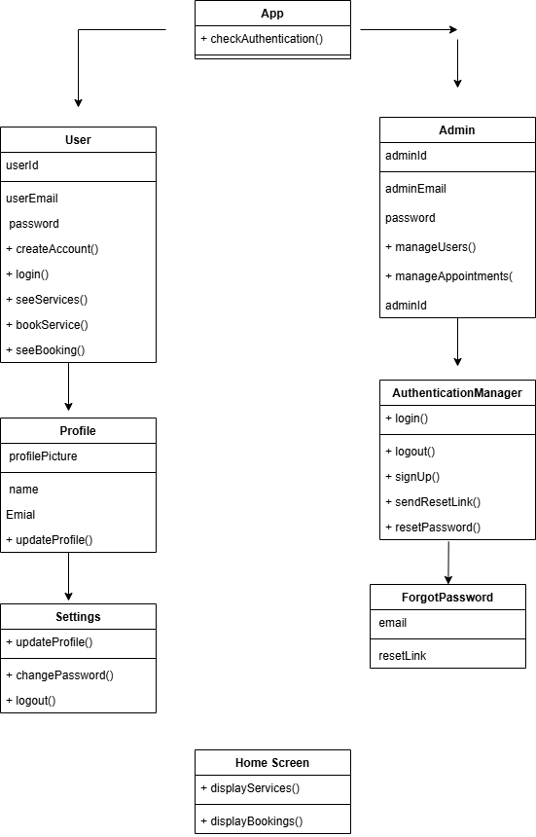
4.4 Design Models [along with descriptions]

5 Implementation
This chapter will discuss implementation details supported by UML diagrams (if applicable). You will not put your source code here. Any of the following sections may be included based on your project.
5.1 Algorithm
In the Car Wash Appointment app, various algorithms are implemented to facilitate core functionalities, such as user management, service browsing, adding services (by admin), and booking appointments. Below is a description of the algorithms used in the major modules, along with pseudocode for clarity.

5.1.1 User Authentication Algorithm
Purpose: To authenticate both Admin and Users using stored credentials.
FUNCTION authenticateUser(email, password)
RETRIEVE userRecord FROM database WHERE email = email
IF userRecord.password == password THEN
IF userRecord.role == "admin" THEN
RETURN "Admin Authenticated"
ELSE
RETURN "User Authenticated"
END IF
ELSE
RETURN "Authentication Failed"
END IF
END FUNCTION

5.1.2 Service Viewing Algorithm
Purpose: To allow users to view available car wash services.
FUNCTION viewServices()
SEND GET request to database for all available services
WAIT for response
IF response contains serviceList THEN
DISPLAY serviceList on HomeScreen
RETURN "Services Displayed"
ELSE
RETURN "Error: No Services Found"
END IF
END FUNCTION

5.1.3 Add New Service Algorithm (Admin Only)
Purpose: To allow admin to add new services to the system.
FUNCTION addService(serviceName, serviceDetails, price)
CREATE newServiceObject with serviceName, serviceDetails, price
SEND POST request to database with newServiceObject
WAIT for response
IF response.status == "success" THEN
RETURN "Service Successfully Added"
ELSE
RETURN "Error: Could Not Add Service"
END IF
END FUNCTION

5.1.4 Book Service Algorithm
Purpose: To allow users to book car wash services at a selected time slot.
FUNCTION bookService(userID, serviceID, dateTime, carDetails)
CREATE appointmentObject with userID, serviceID, dateTime, carDetails
SEND POST request to database with appointmentObject
WAIT for response
IF response.status == "success" THEN
RETURN "Appointment Successfully Booked"
ELSE
RETURN "Error: Booking Failed"
END IF
END FUNCTION

5.1.5 Appointment Management Algorithm (Admin Side)
Purpose: To allow admin to view, update, or cancel user appointments.
FUNCTION manageAppointment(appointmentID, action)
IF action == "view" THEN
RETURN appointment details
ELSE IF action == "update" THEN
UPDATE appointment data in database
RETURN "Appointment Updated"
ELSE IF action == "cancel" THEN
DELETE appointment from database
RETURN "Appointment Cancelled"
ELSE
RETURN "Invalid Action"
END IF
END FUNCTION

5.3 User Interface

- Splash Screen :

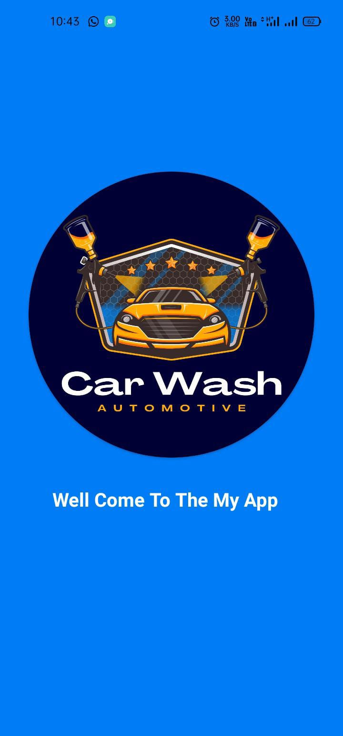

- Authentication screen
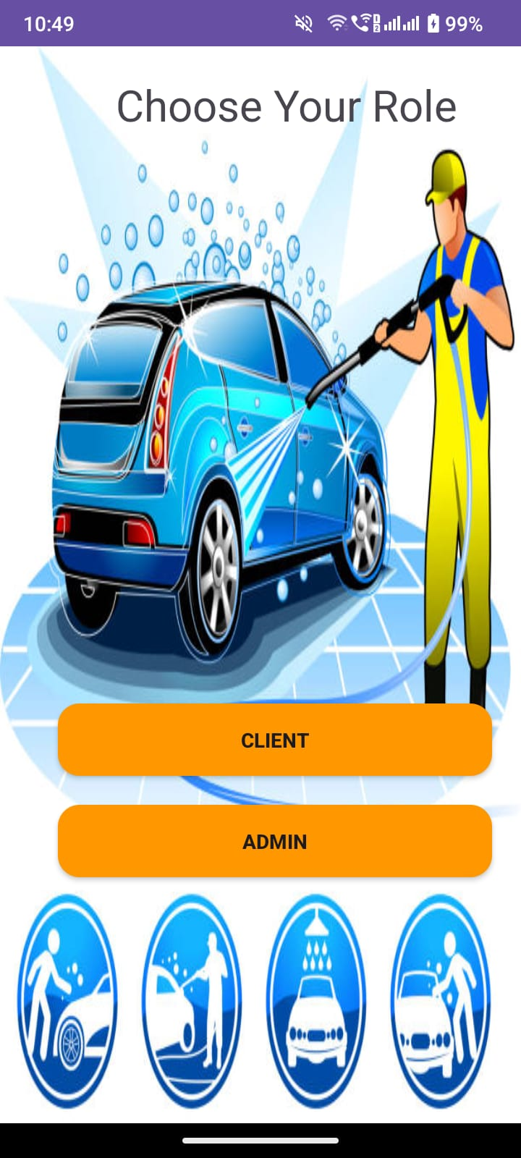

- Home Screen
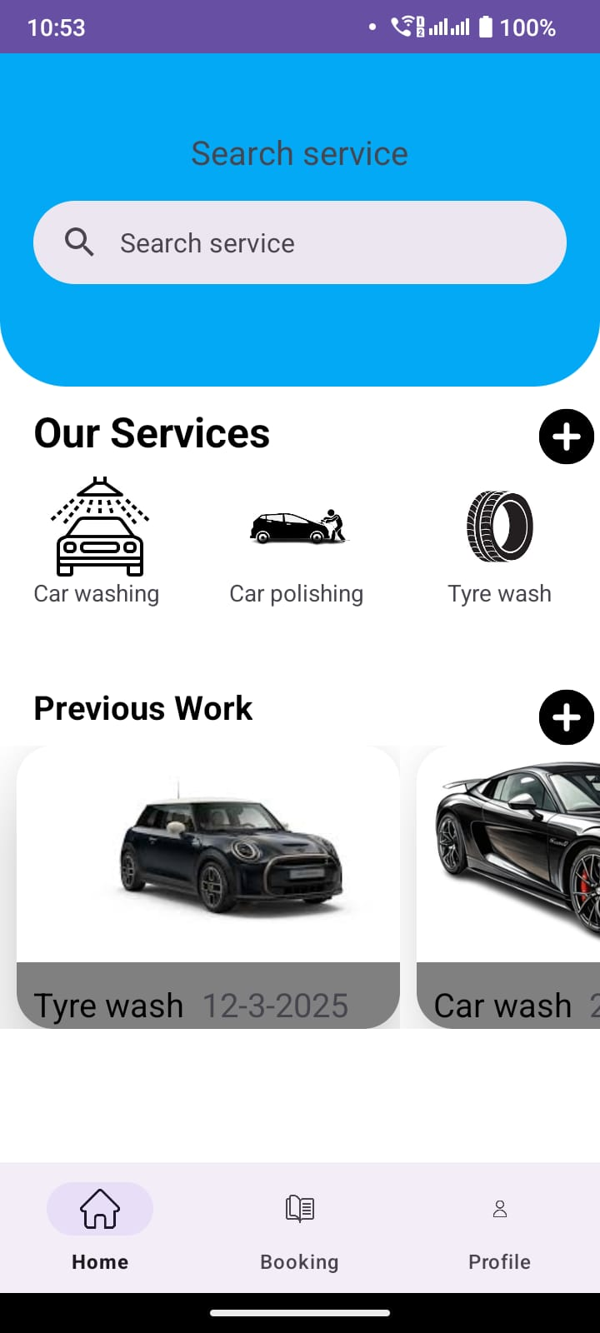

Booking Page
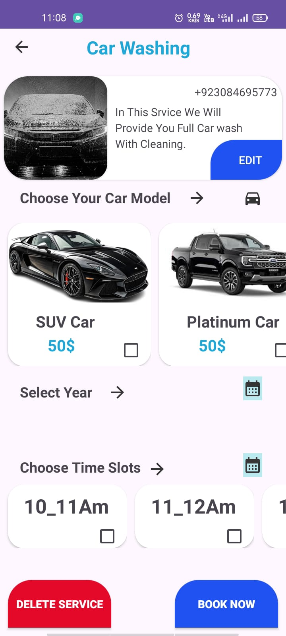

6 Testing and Evaluation
This chapter may include the following sections. (Students are required to perform the testing both manually and automatedly).

6.1 Manual Testing

6.1.1 System testing
Once the Car Wash Appointment system has been successfully developed, testing is performed to ensure that all modules are working as intended. This process also ensures that the system meets all functional and non-functional requirements stated during the design phase.
6.1.2 Unit Testing

Unit Testing 1: Login as Admin/User

Testing Objective: To ensure the login form is working correctly

No. | Test case/Test script | Attribute and value | Expected result | Result
1. | Verify user login upon clicking the login button with valid credentials | Email: user1@gmail.com  Password: 123456 | Successfully logged into the dashboard | Pass
2. | Select any service | Service: Premium Wash | Service details displayed on screen | Pass
3 | Book any service | Date: 20-03-2026  Time: 12:30 PM  Vehicle: Toyota Corolla | Booking is created and confirmation is shown | Pass
4 | Add to booking list | Selected Service: Engine Wash | Service added to user’s booking list | Pass
5 | Make a new admin | Name: Admin2  Email: admin2@carwash.com  Password: admin123 | New admin has been created and saved to database | Pass

Unit Testing 2: Functional Testing

Testing Objective: To ensure the edit profile form is working properly.

No. | Test case/Test script | Test Data | Expected result | Result
1. | Select a car wash service | Select Interior & Exterior Wash from the list of available services | The service details are displayed with price and description | pass
2. | Book a selected service | Choose Premium Wash, select date 20-03-2026, time 12:30 PM | Booking is confirmed and a confirmation message is shown | pass
3 | Add a service to booking list | Select Engine Wash and click Add to Booking | Service is added to user's booking cart/list | pass
4 | View booking history | Logged-in user clicks My Bookings | All previous bookings are listed with status | pass
5 | Create a new admin user | Name: Admin2  Email: admin2@carwash.com  Password: admin123 | New admin user is created and stored in the system | pass

6.1.4 Integration Testing

This phase of testing ensures that different modules of the Car Wash Appointment system are integrated properly and function as a complete system. Integration testing verifies the data flow and functional communication between units such as login, service selection, booking, and admin functions.

No. | Test case/Test script | Attribute and value | Expected result | Result
1. | Login as a registered user and book a service | Username: user001  Password: userpass123  Service: Basic Wash | User logs in successfully and is able to book the selected service | Pass
2. | Login and add a service to booking list | Username: user002  Password: pass4567  Service: Premium Wash | User logs in and the selected service is added to the booking list | Pass
3. | Admin login and add a new service | Admin Email: admin@carwash.com  Password: admin123New Service: Engine Detailing | Admin logs in and adds a new service which appears in service list | Pass
4 | Book a service and receive confirmation | Username: user004  Password: testuser999  Date/Time: 21-03-2026 / 1:00 PM | Booking is successfully created and confirmation is displayed | pass

6.2 Automated Testing:
Tools used:

Tool Name | Tool Description | Applied on [list of related test cases / FR / NFR] | Results
JUnit | A unit testing framework for Java used to test individual methods and classes in isolation. | Login validation (FR1)  Service data model validation  Booking calculation logic | All unit tests passed successfully for valid/invalid inputs
Espresso | UI testing framework by Android for writing automated UI interaction test | User login screen (FR1)  - Service selection UI (FR2)  - Booking screen navigation (FR3) | UI flows performed as expected: buttons, navigation, and field validation passed
Android Emulator (ADB + Instrumentation Tests) | Android Debug Bridge allows you to run full instrumentation tests simulating user behavior on virtual devices. | - End-to-end booking flow test (FR1 to FR4)  - Service availability check  - Admin user creation | All functional flows completed successfully in emulator environment

7 Conclusion and Future Work
This chapter concludes the project and highlights future work.

7.1 Conclusion
The Car Wash Appointment App was developed to address the need for a convenient, efficient, and user-friendly platform that allows users to book car wash services digitally. Through this project, the core functionalities have been successfully implemented, including user authentication, service selection, booking management, and admin panel access.
Users can register or log in, browse available car wash services, select a preferred service, choose a booking date and time, and confirm the appointment with ease. The admin module allows authorized personnel to add, update, or remove services and manage user bookings.
The application was developed using Android Studio with Java, and integration with various components like local databases and system APIs has been tested and validated. Overall, the system meets the functional requirements and provides a smooth experience to both customers and administrators.
7.2 Future Work
Although the current version of the Car Wash Appointment App covers essential features, there is still room for enhancements and further development. The following are potential future improvements:
- Push Notifications: Add real-time reminders and updates for booking confirmations, cancellations, or promotions.
- Live Tracking: Enable users to track service progress or check queue status at the service station.
- Review and Rating System: Let users rate services and provide feedback for quality improvement.
- Multilingual Support: Add multiple language options for better accessibility.
- Admin Analytics Dashboard: Introduce dashboards to monitor total bookings, earnings, peak hours, and service popularity.
- Firebase or Cloud Integration: Store user data and booking records on cloud for real-time sync and multi-device support.

References
References to any book, journal paper or website should properly be acknowledged. Please consistently follow the style. The following are few examples of different resources i.e. journal article, book, and website.
- Lyda M.S. Lau, Jayne Curson, Richard Drew, Peter Dew and Christine Leigh, (1999), Use of VSP Resource Rooms to Support Group Work in a Learning Environment, ACM 99, pp-2. (Journal paper example)
- Hideyuki Nakanishi, Chikara Yoshida, Toshikazu Nishmora and Toru Ishada, (1996), FreeWalk: Supporting Casual Meetings in a Network, pp 308-314 (paper on web) http://www.acm.org/pubs/articles/proceedings/cscw/240080/p308-nakanishi.pdf
- Ali Behforooz & Frederick J. Hudson, (1996), Software Engineering Fundamentals, Oxford University Press. Chapter 8, pp255-235. (book reference example)
- Page Author, Page Title, http://www.bt.com/bttj/archive.htm, Last date accessed. (web site)

